RDYDG-5kVA/50kV AC /DC Withstand Voltage Test Device
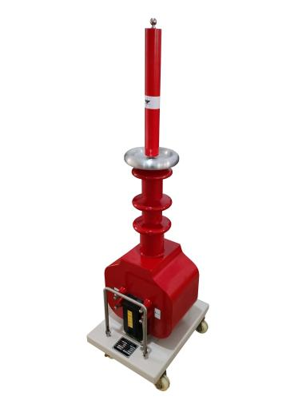
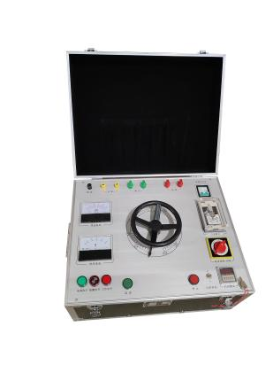
RDYDG-5kVA/50kV AC/DC Withstand Voltage Test Device has the characteristics of small size, light weight, compact structure, complete functions, strong universality, and convenient use. It is particularly suitable for conducting insulation strength tests on various high-voltage electrical equipment, electrical components, and insulation materials under power frequency AC high voltage in power systems, industrial and mining enterprises, scientific research departments, etc. It is an essential and important equipment in high-voltage testing.
The operating table (or control console) is the supporting equipment of the high-voltage test transformer. Perform withstand voltage and leakage tests together with the test transformer.
- Performance characteristics
- The dry test transformer has a compact structure, is maintenance free, and is environmentally friendly.
- Small size, light weight, simple and intuitive wiring, easy to use.
- Good insulation reliability and beautiful appearance.
- Device parameters
Dry-type Test Transformer
Capacity（kVA） | 5
Output voltage (kV) | 50（AC） | 70(DC)
Output current (mA) | 100mA
Input voltage (V) | 200
Input current (A) | 25
Manual Console
Capacity（kVA） | 5
Input voltage (V) | 200
Input current (A) | 25
Output voltage (V) | 0-250V
Output current (A) | 20A
Operating mode | Manual

